Practical Gaming Project

Jack Carroll

T00194823

Project Proposal

Contents

Project Proposal: Conga Craze 3D 2

Storyboard: 2

Issues? 3

Object Form 1 3

Object Form 2 5

# Project Proposal: Conga Craze 3D

<https://www.youtube.com/watch?v=AH-LJ0wiTdg>

<https://www.youtube.com/watch?v=Tn3cpgdiWPI>

<https://answers.unity.com/questions/469899/c-change-light-color-every-few-seconds.html>

<http://www.alphr.com/facebook/1005445/nokia-classic-snake-is-on-facebook-messenger-here-s-how-to-play-it>

<https://i.ytimg.com/vi/-zJdoqmbhfU/hqdefault.jpg>

<https://crowdconga.com.au/conga-for-a-cure>

# Storyboard:

The game will be in 3D format based on the classic Snake Game on the old Nokia button phones which will contain a massive twist to how the game is played. The genre of the game will be a third person arcade game.

Picture

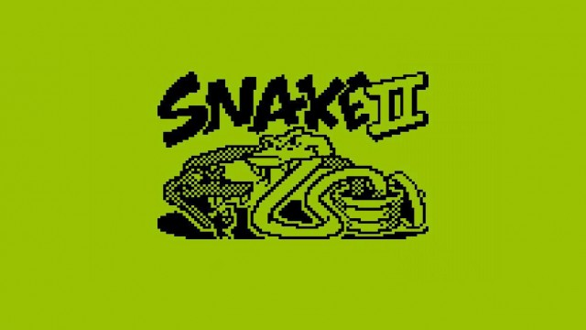

The player will take control of a human conga line, with similar controls to the original Snake game, i.e. Left, Right. However, the controls for movement will be slightly different as the conga line must tilt once the first person in front of the line decides to turn left or right. Acceleration will be considered as well because the line will slow down a little bit once the person in front turns left or right. Control will be given to the line at the beginning of the game once the line automatically moves straight to allow the player to turn at any point.

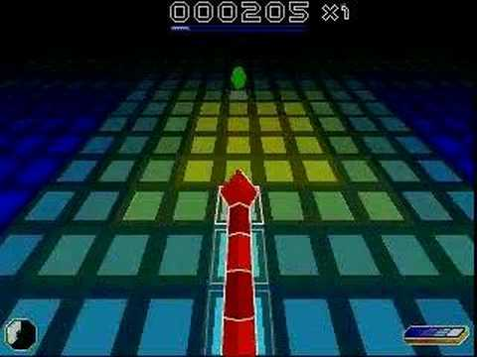

The scene will contain an unusual gobstopper, which will be spawned randomly at the start of the level and positioned in a different spot, and once a gobstopper is eaten by the conga line’s first person, another gobstopper power-up which will be instantiated will be placed in a random spot within the rectangular area. A gulping sound effect will be produced when the gobstopper is taken, and the gobstopper may vary in colour as these power-ups are taken.

A third person view will be used by the camera to face the back of the main player which will be behind the line throughout the game. When the line expands after a gobstopper is eaten, the camera will spread out to create more realism to show the extent of the line and heighten the atmosphere. The camera will also tilt the moment the player in front decides to turn left or right which will move in conjunction with the direction taken by the player.

The stage where the game will be set will consist of a rectangular arena where the conga will occur and there will possibly be an audience watching the event coupled with cheers and screams like a soccer match crowd. As well as that, the floor of the arena might light up frequently to simulate a disco party which will allow different coloured lights to flash in a certain amount of time. A conga-style soundtrack will create the feeling of a Brazilian/Cuban carnival during the game.

The game will finish once the person in front of the conga line collides with another person in the conga line where the line will collapse and the final score will be displayed in the end.

Scores are allocated for the gobstoppers swallowed throughout the game. There might be a multiplier applied every time consecutive gobstoppers are collected.

# Issues?

* Game arena space may become too big
  + Attempt to confine gobstoppers to the arena and not go through wall boundary.
  + Gameplay will be affected if gobstopper outside arena.
* There may be too many people in the conga line if the game lasts long
* Could take up too much RAM and increase the likelihood for the game to crash.
* Animation of individual figures in the line would be too complex for project and cause high CPU Usage which could lead to a system crash.
* Formation of an audience in the arena stands which could be difficult when attempting to create multiple people that could be in the hundreds. May require a simple usage of common shapes, e.g capsule.
* Displaying the score of the gobstoppers collected may be an issue due to the fact that it will need to be reset to zero once the game is over. If a high score is used in the game, the score will have to remain the same unless the line tops that score during a game.
* Saving might have its own issue because it will need to save the high score and load up that score as well as the start-up score at the beginning of the game from a database which will contain the score.

# Object Form 1

Name of Object: Conga Line (Main Object)

Number of possible instances: 1 at first (Expands as gobstoppers collected). May change colour as each one collected. The other gobstoppers are hidden in view while the game runs and appear at a random place within the arena.

Brief description

* Gives the point of view
* Has movement
* Turns to the right/left
* Line instantiates when gobstopper eaten. Various appearances of people spawn each time this happens but not too much variety will be used in order to make the game not as complicated as expected.

Concept picture of Conga Line (Sample – Final product will not be as complex as this)



Detailed information

* Main Movement/Controls
  + turnLeft(): Activated by pressing either left arrow key or “A” key
    - Rotates around Forward axis
    - Conga Line tilts towards left
  + turnRight(): Activated pressing either right arrow key or “D” key
    - Rotates around Forward axis
    - Conga Line tilts towards right
  + moveStraight (): Automatic movement of the line in a straight direction throughout the game. Still moves by itself when a left or right turn is made.
  + mustTurnLeft() method will add confirmation to whether the player should turn left when “A” key pressed
  + mustTurnRight() method will add confirmation as to whether the player should turn right when “” key pressed
* Collision Detection

OnCollisionEnter will be most certainly used for detecting the collisions between the main game objects in the game.

* + Collision with Gobstopper (Increases score)

Using pickUpGob() method to communicate message to player in order to destroy gobstopper through using

* + Collision with wall (Also results in game over)

gameOver() method used in this case

* + Collision with person in line itself which leads to the game ending and resetting to the start of the game (Main Menu). gameOver() method also implemented here.

destroyConga() method used here to destroy conga line

* + Bounding sphere
* Game Specific Data
  + Current Score
  + High Score

Both of these will be managed in the Score Manager class

* Core data
  + Position
  + Velocity
  + Acceleration
  + Bounding Sphere
* Core Methods
  + Draw
  + Update
  + LoadContent
  + Initialise

# Object Form 2

Name of Object: Gobstopper

Number of possible instances: Variable (Varies depending on when game ends). Probably up to 50.

Brief description

* The gobstopper is the power-up that the person in front of the conga line will collect within the arena to liven up the concert atmosphere and to expand the line.

Concept picture of Gobstopper(What gobstopper may appear like at start of game before changing colours once collected.)



Detailed information

* Movement/Controls
  + - Random position and appropriate timing once eaten by person in front of line to spawn another gobstopper

GameManager class will manage spawning of gobstoppers each time the front person gobbles up the power up. (itemSpawn() method will take charge of the spawning of gobstoppers)

* + - One gobstopper at a time in the arena. Stays until the gobstopper eaten. (collectItem() method will manage the collected gobstoppers so that another gobstopper may appear randomly.)
    - Gobstopper will have no controls. It will remain static where it will not move by itself in contrast to the line.
* Collision Detection
  + Collision with conga line
  + Bounding sphere
* Game Specific Data
  + Generation data
  + Scale
* Core data
  + Position
* Core Methods
  + Draw
  + Update
  + LoadContent
  + Initialise

# References